**Project Design Phase-II**

**Technology Stack (Architecture & Stack)**

|  |  |
| --- | --- |
| Team ID | PNT2022TMID23657 |
| Project Name | Project –Plasma Donor Application |
| Maximum Marks | 4 Marks |

**Technical Architecture:**

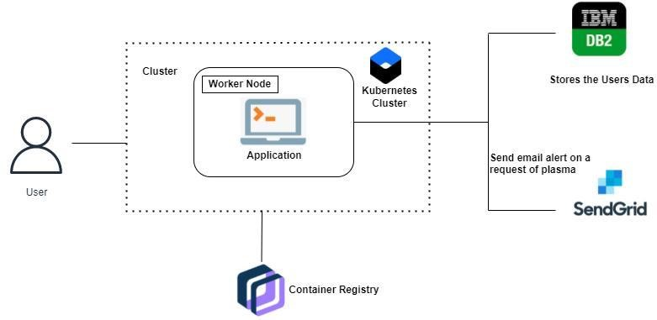

**Table-1 : Components & Technologies:**

|  |  |  |  |
| --- | --- | --- | --- |
| **S.No** | **Component** | **Description** | **Technology** |
| 1. | User Interface | How user interacts with application. Web UI, Mobile App, Chatbot etc. | HTML, CSS, JavaScript, Python, Flask |
| 2. | Register to website | The user can able to register in website and fill their details. The user details are Stored in IBM DB2 securely. | Flask app using Kubernetes cluster, IBM DB2. |
| 3. | Login to website | The user interact with the website to login into account. The user details are verified by comparing it with details stored in IBM DB2 | Flask app using Kubernetes cluster, IBM DB2. |
| 4. | Request for Donor/Register for donating | The user interact with the website to request for plasma Donor/register for willing to donate plasma. | Flask app using Kubernetes cluster, IBM DB2. |
| 5. | Upload proof in website | The user can able to upload the vaccination certificate and other proofs. | Container registry, |
| 6. | Cloud Database | Database Service on Cloud | IBM DB2, IBM Cloudant etc. |
| 7. | File Storage | File storage requirements | IBM Block Storage or Other Storage Service or Local Filesystem |
| 8. | External API-1 (Email Alert) | To send email alerts to donor when a person requesting Plasma Donor. | SendGrid. |
| 9. | Machine Learning Model | Machine Learning Model can be used for Chatbot. | IBM Watson. |
| 10. | Infrastructure (Server / Cloud) | Application Deployment on Local System / Cloud | Local, Cloud Foundry, Kubernetes. |

**Table-2: Application Characteristics:**

|  |  |  |  |
| --- | --- | --- | --- |
| **S.No** | **Characteristics** | **Description** | **Technology** |
| 1. | Open-Source Frameworks | Flask is an open source framework in python. Similarly Docker is also used. | Flask , Docker |
| 2. | Security Implementations | Only registered users who have specific privileges has access to the website. | IBM DB2 |
| 3. | Scalable Architecture | 3 – tier architecture, presentation tier, application tier, data tier | Python, IBM cloud services |
| 4. | Availability | The application can be available for user at any time. | Kubernetes, Docker |
| 5. | Performance | The application can handle multiple requests per second. | Kubernetes cluster, IBM |